Analysis of Return Data using CAPM Regression and 3-Factor Model Regression
Name
Date
Institution

Analysis of Return Data using CAPM Regression and 3-Factor Model Regression
Question 1
1A: Calculate the average raw return and the average excess return of Mystery Security #1. (4 points)
(i). Average raw return= sum of return for the Mystery Security 1÷ Total Months Traded
Average raw return (Mystery Security 1)= 118.76 ÷ 240 months
Average raw return= 0.4948*100%
The Mystery Security 1 experienced an Average Return of (0.4948) 49.48% upon its maturity.

(ii). Average excess return= (Sum of Return of Mystery Security – (Market return – Risk-Free rate return) ÷ Total Months Traded
Average excess return = (118.76 - 163.41) ÷ 240
=-44.65/240
=-0.1860*100%
= (18.60%)
The Mystery Security 1 experienced a deficit of 18.60%, which indicate a loss in average return upon its maturity.

1B: Estimate a CAPM regression for Mystery Security #1 and report the CAPM alpha, CAPM beta, and R-squared of the CAPM regression. (6 points)
Figure 1: Estimated CAPM Regression for Mystery Security 1
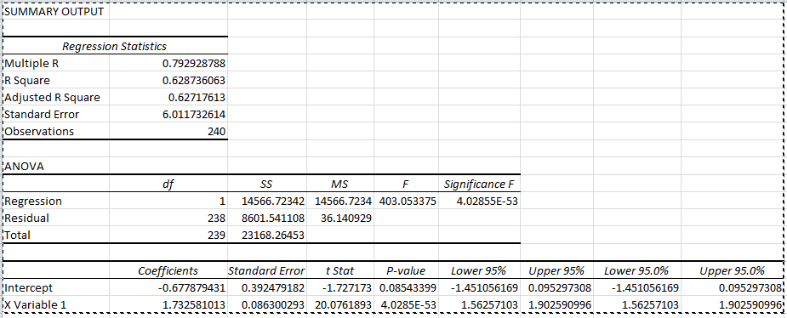
The figure one above reveals a strong performance for the Mystery Security 1 because of a positive beta and R-Square of 62.9%.
Therefore,
The estimated CAPM Alpha (y-intercept) = -0.68
The estimated CAPM Beta (x-intercept) = 1.7
The estimated R-Squared of CAPM Regression = 0.6287

1C: Estimate a 3-Factor Model regression for Mystery Security #1 and report the 3-Factor alpha, 3-Factor market beta, 3-Factor size beta, 3-Factor value beta, and R-squared for the 3-Factor Model. (10 points)
Figure 2: 3-Factor model Regression for Mystery Security 1
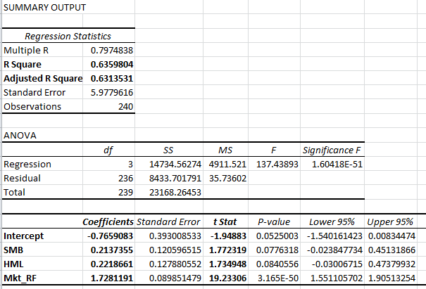
Using the figure two above, we can identify an underperformance of the Mystery Security 1 using the regression-based benchmark for the alpha measure of -0.77. Therefore,
The estimated 3-FM CAPM Alpha (intercept) = -0.77
The estimated 3-FM Market Beta (Coefficient Mkt_RF) = 1.73
The estimated 3-Factor size beta= 0.21
The estimated 3-Factor value beta= 0.22
The estimated R-Squared for the 3-FM = 0.64

1D: What is the identity of Mystery Security #1? You can at least describe some of the key characteristics of the Mystery Security #1. (3 points)
The Mystery Security #1 has the following distinctive attributes that are evident from a single-factor and three-factor regression analyses.
1. The security exhibit high volatility to the market risk because of a beta 1.73
2. The security is an example of a growth-stock because of HML Coefficient closer to zero (0). The HML coefficient 0.22 is close to zero (0), which implies the security has an attributes of a growth portfolio.
3. The security is a large capitalization portfolio because of the SMB Coefficient 0.21, which is close to a zero (0).
Question 2
2A: Calculate the average raw return and the average excess return of Mystery Security #2. (4 points)
(i). Average raw return= sum of return for the Mystery Security 1÷ Total Months Traded
Average raw return (Mystery Security 1) = 335.61 ÷ 240 months
Average raw return= 1.3984*100%
The Mystery Security 1 experienced an Average Return of (1.3984) 139.84% upon its maturity.

(ii). Average excess return= (Sum of Return of Mystery Security – (Market return – Risk-Free rate return) ÷ Total Months Traded
Average excess return = (335.61-163.41) ÷ 240
=172.20 ÷ 240
=-0.7175*100%
= 71.75%
The Mystery Security 1 experienced a surplus of 71.75%, which indicate a gain in average return upon its maturity.

2B: Estimate a CAPM regression for Mystery Security #2 and report the CAPM alpha, CAPM beta, and R-squared of the CAPM regression. (6 points)
Figure 3: Estimated CAPM Regression for Mystery Security 2
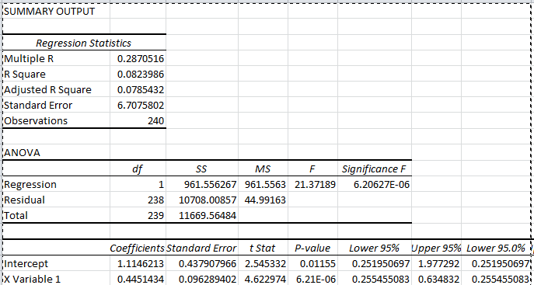
The figure one above reveals a strong performance for the Mystery Security 1 because of a positive beta and R-Square of 8.2%.
The estimated CAPM Alpha (y-intercept) = 1.11
The estimated CAPM Beta (x-intercept) = 0.5
The estimated R-Squared of CAPM Regression = 0.0824

2C: Estimate a 3-Factor Model regression for Mystery Security #2 and report the 3-Factor alpha, 3-Factor market beta, 3-Factor size beta, 3-Factor value beta, and R-squared for the 3-Factor Model. (10 points)
Figure 4: Estimated 3-Factor Model Regression for the Mystery Security 2
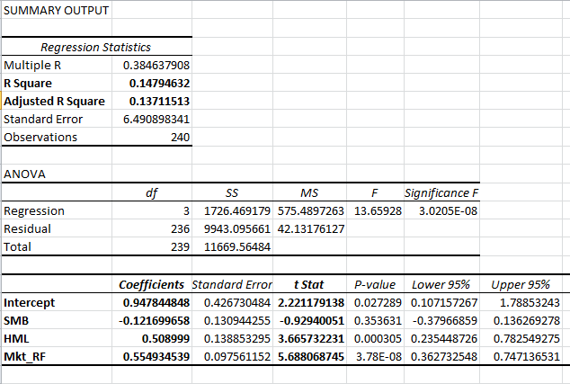
Using the figure 4 above, we can identify an over-performance of the Mystery Security 2 using the regression-based benchmark for the alpha measure of 0.95. Therefore,
The estimated 3-FM CAPM Alpha (intercept) = 0.95
The estimated 3-FM Market Beta (Coefficient Mkt_RF) = 0.55
The estimated 3-Factor size beta= -0.12
The estimated 3-Factor value beta= 0.51
The estimated R-Squared for the 3-FM = 0.15

2D: What is the identity of Mystery Security #2? You can at least describe some of the key characteristics of the Mystery Security #2. (3 points)
1. The security has a weak volatility to the market risk because of a beta coefficient 0.4, which indicate a weak and positive correlation to the changes in market risk. Therefore, changes in market risks generate small amount of risks to the portfolio.
2. The SMB Coefficient of -0.21 indicate a large capitalization because of the close proximate to the zero (0) mark.
3. The security represents a Value-portfolio because of the HML Coefficient of 0.51. A HML loading, which is greater than 0.3 depicts that a portfolio has the features of a Value investment.
Question 3
3A: Calculate the average raw return and the average excess return of Mystery Security #3. (4 points)
(i). Average raw return= sum of return for the Mystery Security 1÷ Total Months Traded
Average raw return (Mystery Security 1) = 284.43 ÷ 240 months
Average raw return= 1.1851*100%
The Mystery Security 1 experienced an Average Return of (1.1851) 118.51% upon its maturity.

(ii). Average excess return= (Sum of Return of Mystery Security – (Market return – Risk-Free rate return) ÷ Total Months Traded
Average excess return = (284.43 - 163.41) ÷ 240
= 121.02 ÷ 240
= 0.5043*100%
= 50.43%
The Mystery Security 1 experienced a surplus of 50.43%, which indicate a gain in average monthly return upon its maturity.

3B: Estimate a CAPM regression for Mystery Security #3 and report the CAPM alpha, CAPM beta, and R-squared of the CAPM regression. (6 points)
Figure 5: Estimated CAPM Regression for the Mystery Security 3 using a single-factor
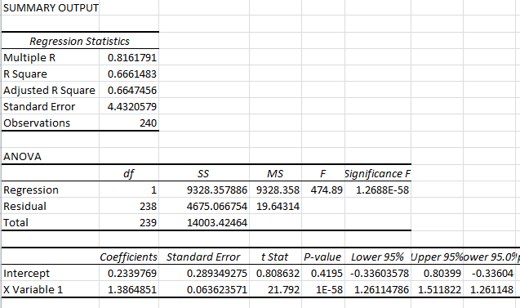
The figure 5 above reveals a strong performance for the Mystery Security 3 because of a positive and strong beta and R-Square of 66.6%.
Therefore,
The estimated CAPM Alpha (y-intercept) = 0.23
The estimated CAPM Beta (x-intercept) = 1.4
The estimated R-Squared of CAPM Regression = 0.6661

3C: Estimate a 3-Factor Model regression for Mystery Security #3 and report the 3-Factor alpha, 3-Factor market beta, 3-Factor size beta, 3-Factor value beta, and R-squared for the 3-Factor Model. (10 points)
Figure 6: Estimated 3-Factor Model Regression for the Mystery Security 3
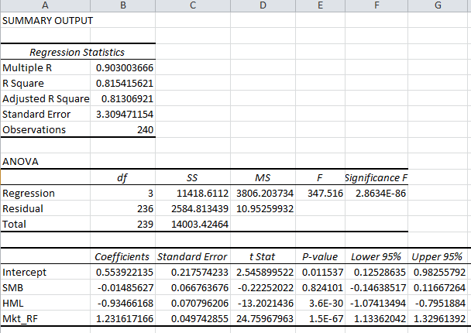
Using the figure 6 above, we can identify an average performance of the Mystery Security 3 using the regression-based benchmark for the alpha measure of 0.55. Therefore,
The estimated 3-FM CAPM Alpha (intercept) = 0.55
The estimated 3-FM Market Beta (Coefficient Mkt_RF) = 1.23
The estimated 3-Factor size beta= -0.01
The estimated 3-Factor value beta= -0.93
The estimated R-Squared for the 3-FM = 0.82

3D: What is the identity of Mystery Security #3? You can at least describe some of the key characteristics of the Mystery Security #3. (3 points)
1. The security is the second-most volatile asset because it has a beta coefficient of 1.40, which implies that the asset exhibit 40% more volatility compared to the entire market portfolio.
2. The SMB Coefficient of -0.01 portrays the security as a largely capitalized asset. Using a rule of thumb, an asset with an SMB Loading of zero (0) indicates a large capitalization size for the security.
3. The R-Squared loading of 0.82 portrays the security to have a fairly decent fit with the data because 82% of the monthly returns are impacted by large capitalization, high value, and market risks. Therefore, an investor can conclude that the Mystery Security #3 is a Growth portfolio because of it has a HML Coefficient of -0.93.
Question 4
4A: Does Mystery Security #1 have a lot or a little idiosyncratic risk? Why? (2 points)
The Mystery Security #1 has little idiosyncratic risk because of the high and identical market beta. The security has a market beta of 1.73, which implies a high volatility to the changes in the market parameters including risks and returns. Therefore, the security can be interpreted to exhibit high systematic risks because of the high market beta that is above 1.0.
4B: Does Mystery Security #2 have a lot or a little idiosyncratic risk? Why? (2 points)
The Mystery Security #2 has a lot of idiosyncratic risks because of the low beta, which is 0.44. Further, the security reveals a lower market beta coefficient of 0.55 in a three-model factor regression, which indicates less volatility to the changes in market parameters. Therefore, the security is susceptible to endemic risks, which necessitates diversification as an appropriate measure to mitigate the effects of idiosyncratic risks.
4C: Does Mystery Security #3 have a lot or a little idiosyncratic risk? Why? (2 points)
The Mystery Security #3 has little idiosyncratic risk because of the high market beta, which is above 1.0. The security has a market beta of 1.4, which implies a high volatility to the changes in the market parameters including risks and returns. Therefore, the security can be interpreted to exhibit high systematic risks because of the high market beta that is above 1.0.

Question 5
5A: For Mystery Security #1, what portfolio combination of the U.S. Stock Market and Treasury Bills will yield the same CAPM beta? (5 points)
The combination of the U.S. Stock market and Treasury Bills to yield a CAPM Beta of 1.73 can be yielded using the formula r- RF= beta*(K_{m}-R_{f}) + alpha
Where, r- R_{f} =combination of U.S. Stock Market and Treasury Bills.
Note: the Treasury Bills represents the risk-free return rate in a CAPM formula
r- R_{f}= beta*(K_{m}-R_{f}) + alpha
r-R_{f} = 1.74* (1.39) + (-0.6779)
r-R_{f} = 2.4186-0.6779
r-R_{f} = 1.740
The details of the security as at 02/2004 provides the right combination of stock market return and the treasury bills yield a similar CAPM beta of 1.74. Therefore, the right combination should U.S. Stock Market return of 146% (1.46) and Treasury Bills 6% (0.06).

5B: For Mystery Security #2, what portfolio combination of the U.S. Stock Market and Treasury Bills will yield the same CAPM beta? (5 points)
The combination of the U.S. Stock market and Treasury Bills to yield a CAPM Beta of 0.4451 can be yielded using the formula r- RF= beta*(K_{m}-R_{f}) + alpha
Where, r- R_{f} =combination of U.S. Stock Market and Treasury Bills.
Note: the Treasury Bills represents the risk-free return rate in a CAPM formula
r- R_{f}= beta*(K_{m}-R_{f}) + alpha
r-R_{f} = 0.4451* (-1.5747) + 1.1146
r-R_{f} = -0.66765+1.1146
r-R_{f} = 0.4451
The details of the security as at 10/1995 provides the right combination of stock market return and the treasury bills yield a similar CAPM beta of 0.4451. Therefore, the right combination should U.S. Stock Market return of 197% (-1.97) and Treasury Bills 47% (0.47).

5C: For Mystery Security #3, what portfolio combination of the U.S. Stock Market and Treasury Bills will yield the same CAPM beta? (5 points)
The combination of the U.S. Stock market and Treasury Bills to yield a CAPM Beta of 1.3865 can be yielded using the formula r- RF= beta*(K_{m}-R_{f}) + alpha
Where, r- R_{f} =combination of U.S. Stock Market and Treasury Bills.
Note: the Treasury Bills represents the risk-free return rate in a CAPM formula
r- R_{f}= beta*(K_{m}-R_{f}) + alpha
r-R_{f} = 1.3865* (0.8331) + 0.2340
r-R_{f} = 1.1554+ 0.2340
r-R_{f} = 1.389
The details of the security as at November 2012 provides the right combination of stock market return and the treasury bills yield a similar CAPM beta of 1.3865. Therefore, the right combination should U.S. Stock Market return of 79% (0.79) and Treasury Bills 1% (0.01).

Reference
Bernstein, W. (2001). “Rolling your own: Three Factor Analysis” The Efficient Frontier. Retrieved from http://www.efficientfrontier.com/ef/101/roll101.html

